**Q1- Create table of table name: EMPLOYEES and add 6 rows and then Create View of name emp_view and the column would be Employee_id, Last_Name,salary and department_id only?**

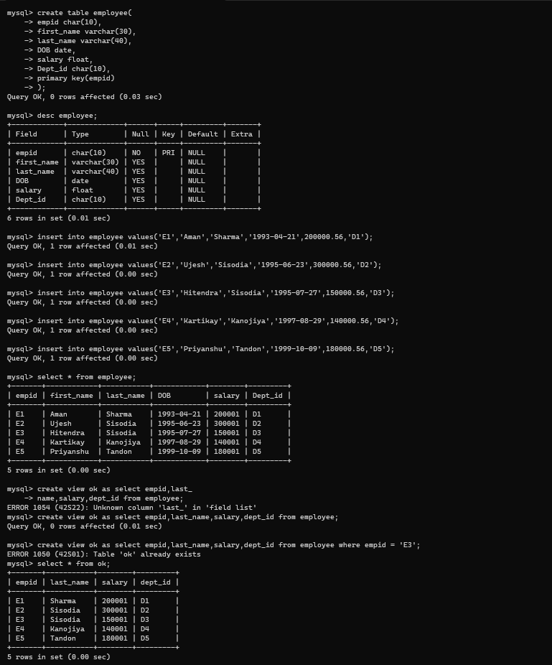

**Q2- Insert values into view (remove the NOT NULL constraint and then insert values)?**

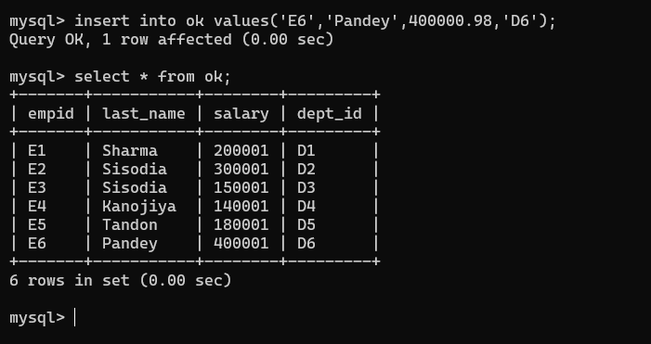

**Q3-** **Modify, Operation in view**

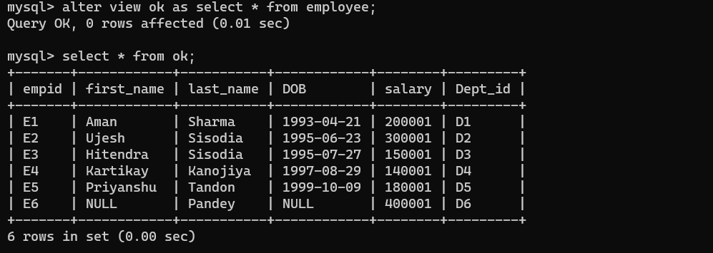

**Q4- Delete operation in view**



**Q5- drop operation in view**



**Q6- Creates a view named salary_view. The view shows the employees in department 20 and their annual salary**

